Sarah (Baker) Higgins
May 13, 1821 – April 30, 1852

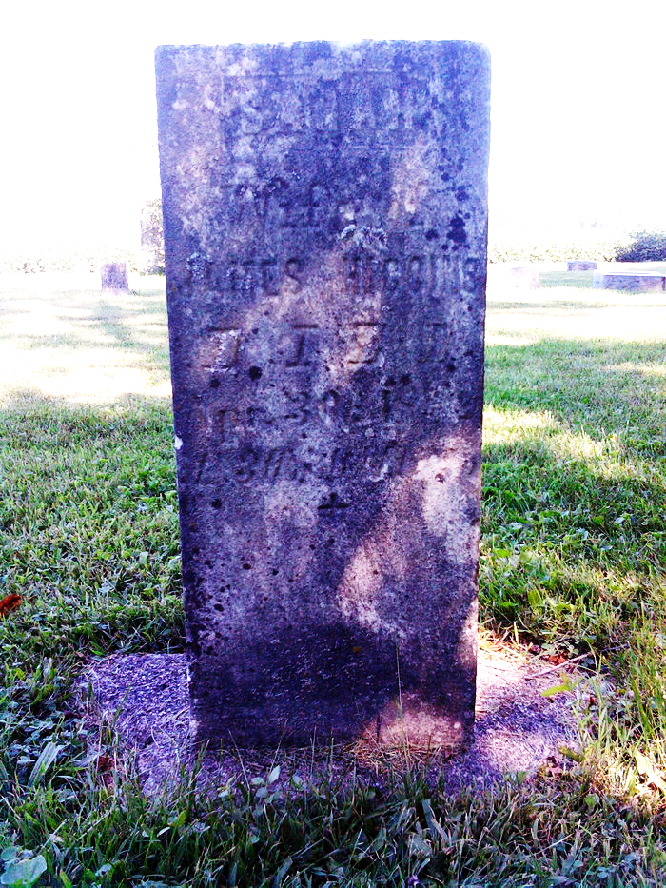
Photo by Thomas Liby

Sarah Baker from tree Hoosier Dad / Tex Mom

Birth 1822 Ohio, USA
Marriage 9 Oct 1845 Shelby, Richland, Ohio, USA
Residence 1850 Wells, Indiana, USA
Death 30 Apr 1852
Father William Baker (Born 1794)
Spouse James Harvey Higgins (1818-1897)
8821 People 3 Records 3 Sources
**

Ohio, U.S., County Marriage Records, 1774-1993

Name Sarah Baker
Gender Female
Marriage Date 9 Oct 1845
Marriage Place Shelby, Ohio, USA
Spouse James Higgins
Film Number 000562858

