Patricia Lee (Ifer) Higgins
October 23, 1929 -

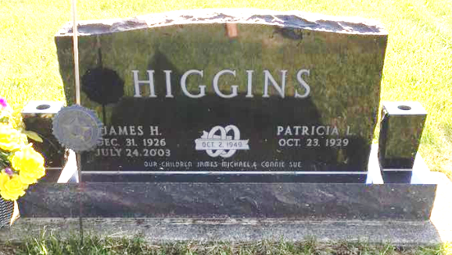
Photo by Scott Shoup

Patricia Lee Ifer
in the Indiana, U.S., Marriages, 1810-2001

Name Patricia Lee Ifer
Gender Female
Race White
Age 20
Event Type Marriage Registration (Marriage)
Birth Date 23 Oct 1929
Birth Place Allen, Indiana
Marriage Date 29 Sep 1949
Marriage Place Indiana, United States
Residence Place Montpelier, Indiana
Father Homer L Ifer
Mother Mary Grisell
Spouse James H Higgins
Page 272
FHL Film Number 002318672

