Mary E. (Van Emon) Higgins
August 15, 1917 – January 28, 1993

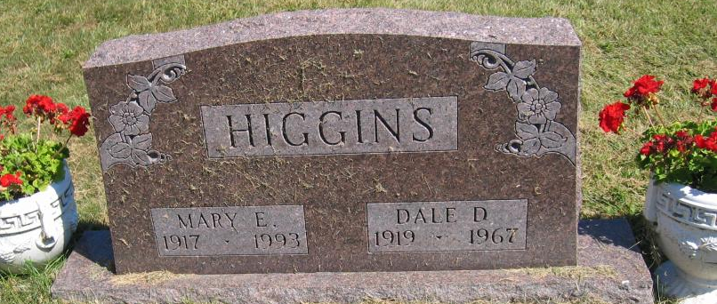
Photo by Tombstoner & Family

Mary E Higgins
in the Indiana, U.S., Death Certificates, 1899-2017

Name Mary E Higgins
Gender Female
Race White
Marital Status Widowed
Age 75
Birth Date 15 Aug 1917
Birth Place Wells County, Indiana
Death Date 28 Jan 1993
Death Place Bluffton, Wells, Indiana, USA
Death Registration Date 1993
Father Asa Van Emon
Mother Millie Prilliman
Informant Tommy Higgins; son; Bluffton, Indiana
Burial January 31, 1993; Bethel Cemetery; Bluffton, Indiana

