Mary Higgins
1850 – April 4, 1851

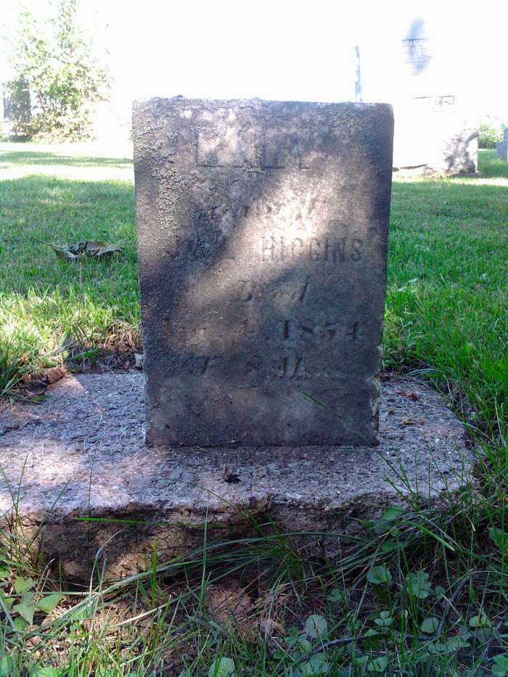
Photo by Thomas Liby

No further information found at this time.

