Lewis Higgins
1855 – November 2, 1880

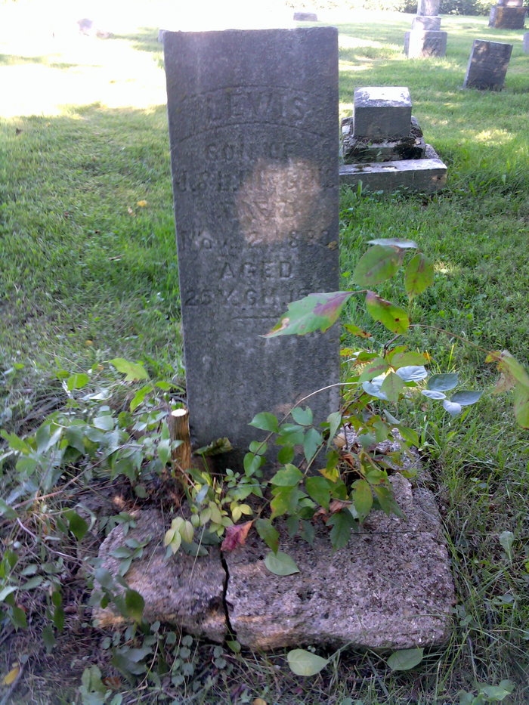
Photo by Thomas Liby

Lewis Higgins from Shoemaker Family Tree

Birth 1855 Indiana, USA
Residence 1880 Wells, Indiana, USA
Death 2 Nov 1880 Bluffton, Wells, Indiana, USA
Father James Harvey Higgins (1818-1897)
Mother Lydia Chalfant (1814-1884)
573 People 4 Records 10 Source

