James H. Higgins
December 31, 1926 – July 24, 2003

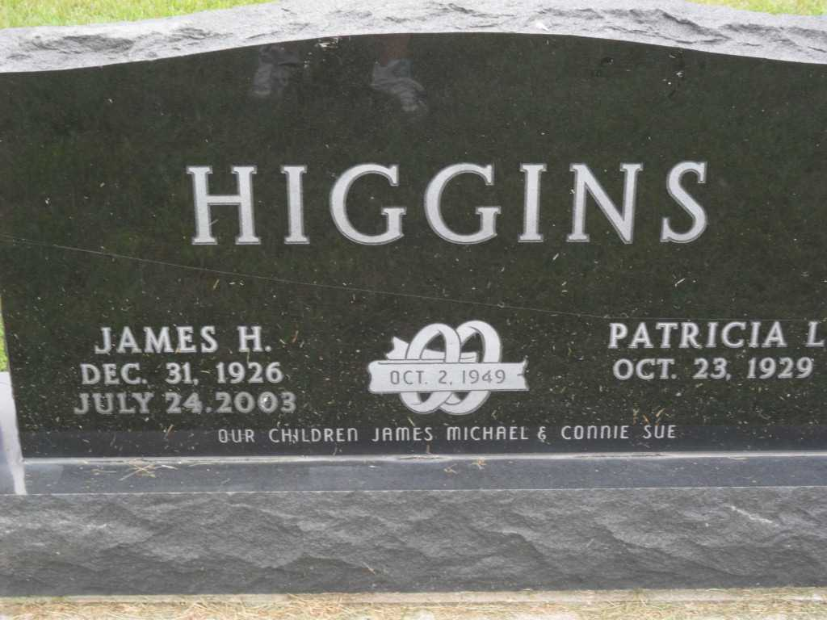
Photos by Pretty Little Grave Seekers

JAMES H. HIGGINS, 76, of Bluffton, died Thursday, July 24, 2003, at Bluffton Regional Medical Center. Born December 31, 1926, in Bluffton, to Dr. Earl and Pearl (Ditzler) Higgins, he married Patricia Ifer on Oct. 2, 1949, in Bluffton. He was a retired farmer, an Army veteran, and a 50 year member of Masonic Lodge #212, Pennville, a member of Petroleum United Methodist Church and American Legion Post 111. Survivors include his wife, Patricia; a son, James Michael Higgins of Fort Wayne; a daughter, Mrs. Connie Sue (Ronald) Hose of Clear Springs, Md.; two grandchildren, James Travis Higgins and Kara Brooke Hose; and a sister, Mrs. Hermenia Schlagenhauf of Carmel. He was preceded in death by two brothers, Dale and Joe Higgins, and a sister, Katheryn Hott. Service is 1 p.m. Monday at Goodwin Memorial Chapel, with the Rev. Bob Cahoon officiating. Calling is from noon to 8 p.m. Sunday at the chapel, with Masonic service at 7 p.m. Burial at Bethel Cemetery, with American Legion graveside service. Memorials to Petroleum Methodist Church.

Journal Gazette, The (Fort Wayne, IN) - Saturday, July 26, 2003

Contributed by Jane Edson

