James Harvey Higgins
December 20, 1818 – October 2, 1897

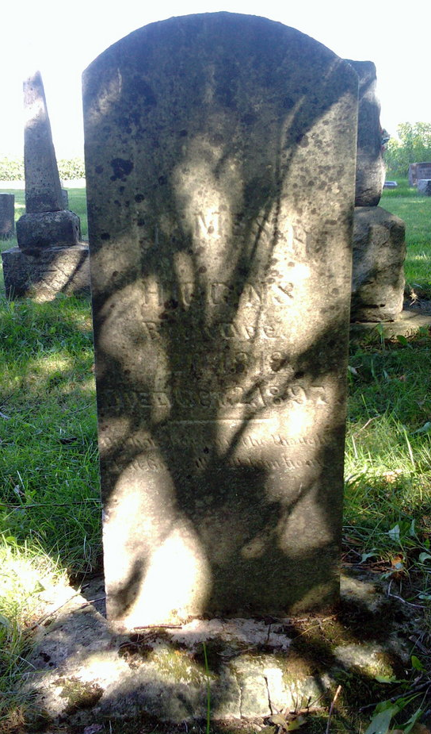
Photo by Thomas Liby

James Harvey Higgins from tree Higgins Family Tree

Birth 20 Dec 1818 Scioto, Ohio, USA
Residence 1880 Wells, Indiana, USA
Marriage 26 May 1885 Indiana, USA
Death 2 Oct 1897 Wells, Indiana, USA
Father John Higgins (1775-1860)
Mother Martha Higgins (1782-1860)
Spouse Mary A Weer
200 People 5 Records 7 Sources
**

Web: Indiana, U.S., Marriage Index, 1806-1861

Name James H Higgins
Marriage Date 16 Nov 1852
Marriage Place Wells, Indiana, USA
Spouse Lydia Chalfant
URL https://digital.statelib.lib.in.us/legacy/search.aspx?index=3
**

Indiana, U.S., Marriage Certificates, 1960-2012

Name James H Higgins
Gender Male
Marriage License Date 26 May 1885
Marriage Date 26 May 1885; Marriage Place Wells, Indiana, USA
Spouse Mary A Weer
Officiator W H Tinker

