James Higgins
1848 – April 15, 1852

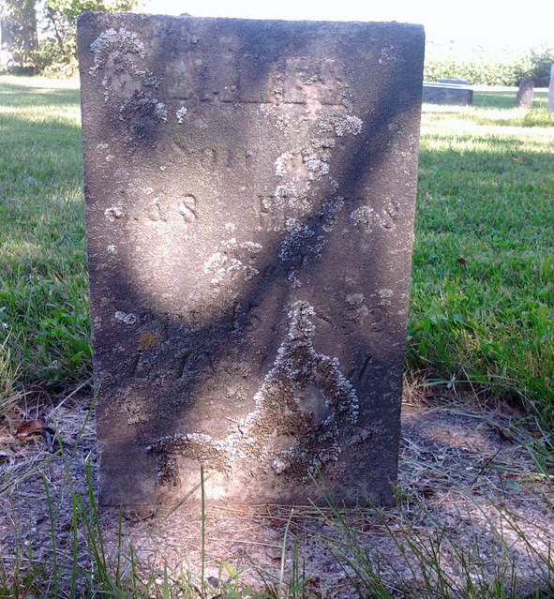
Photo by Thomas Liby

No further information found at this time.

