Carol J. (Cline) Higgins
January 27, 1948 – July 14, 2020

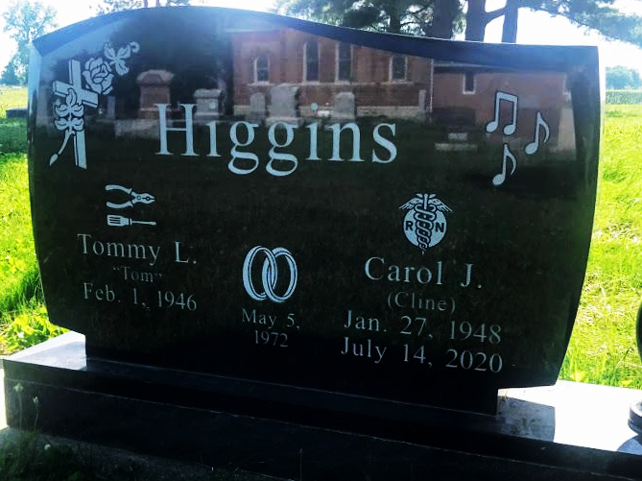
Photo by SMMR

Carol J. Higgins, 72, of Bluffton, passed away at Lutheran Hospital in Fort Wayne on Tuesday, July 14, 2020. Carol was born on January 27, 1948 in Columbus, Ohio to Robert A. and Betty L. (Grimsley) Cline. Carol was a 1966 graduate of P. A. Allen (Bluffton) High School. She became a registered nurse following graduation from Lutheran Hospital School of Nursing in 1970, and entered into a distinguished career in nursing, first in the Cardiac Critical Care Service at Lutheran Hospital in Fort Wayne and then at Markle Medical Clinic in Bluffton, where she was on staff for 39 years. Carol married Tommy L. Higgins at First United Methodist Church in Bluffton on May 5, 1972.
She was an active musician in her student days, playing French horn and singing in choirs and an esteemed vocal trio with classmates Billy (Beatty) Kreigh and Claudia (Cotton) Gipson, and as an adult singing in the Chancel Choir and ringing in the Bellaires Handbell Choir at First United Methodist Church in Bluffton. In the year 2000, she appeared as Ethel Toffelmier (the “pianola girl”) in “The Music Man,” the inaugural production by Wells Community Theater in Bluffton.
Carol was a lifelong member of First United Methodist Church of Bluffton and was an associate member of Tri Kappa sorority, as well as LiGHT women’s service organization.
She loved traveling throughout the United States with her husband Tom, dining with their friends, and enjoying country living at their farm home south of Bluffton.
Later in life, she engaged in a generous ministry of card-writing to a wide circle of friends and acquaintances, creating and maintaining relationships with hundreds of people around the country. In her outreach to others throughout her life, she embodied the spirit of this quote found in her college yearbook: “If I can stop one heart from breaking, I shall not live in vain.”
Carol is survived by her husband of 48 years, Tom, her dedicated and loving caregiver the past seven years; daughter Joy (Paul) R. Chen of Fishers, Indiana; granddaughter Cassie Chen of Fishers, brother David (Judy) Cline of Deephaven, Minnesota; brother Bill (Jane) Cline of Fort Wayne; nieces April (Jacey) Poulson and Bethany Cline; nephews Todd (Jane) Higgins, Rodd Higgins, and Joe (Kaylin) Cline; as well as great nieces and great nephews.
She was preceded in death by her parents and by daughter, Amy L. Higgins.
Funeral arrangements have been entrusted to Thoma/Rich, Lemler Funeral Home in Bluffton. Calling hours will be held from 12 Noon to 5 P.M. on Sunday (July 19, 2020) at the funeral home. Funeral services will be held at 11:00 A.M. on Monday (July 20, 2020) at First United Methodist Church in Bluffton, with calling for one hour prior to the service. Pastor Sherrie Drake and Rev. Cindy Osgood will officiate. Burial will follow at Bethel Church Cemetery in rural Bluffton.
Memorials may be made in Carol’s memory to Lutheran Hospital School of Nursing, Class of 1970 Scholarship Fund, Angel of Hope Park through the Wells County Foundation, or First United Methodist Church music department.
The safety of the family and all visitors is our utmost priority. For everyone’s safety, we ask that you practice social distancing. Masks are required for visitation and for Carol’s service at the church. We appreciate your cooperation and patience.

Thoma/Rich, Lemler Funeral Homes, Wells County, Indiana

