Arnetta Pearl (Ditzler) Higgins
July 20, 1886 – May 18, 1943

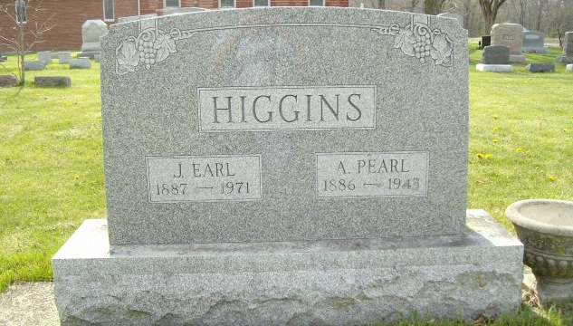
Photo by smalltown

Arnetta Pearl Higgins
in the Indiana, U.S., Death Certificates, 1899-2017

Name Arnetta Pearl Higgins
[Arnetta Pearl Ditzler]
Gender Female
Race White
Marital Status Married
Age 56
Birth Date 20 Jul 1886
Birth Place Wells County, Indiana
Death Date 18 May 1943
Death Place Rural, Wells, Indiana, USA
Death Registration Date 1943
Father John Ditzler
Mother Bulunda Brickley
Spouse Earl Higgins; age 57
Informant Dr. Earl Higgins; Bluffton, Indiana
Burial May 21, 1943; Bethel Cemetery; Harrison Township

