Lillian D. (Ripple) Herron
December 11, 1915 – December 21, 2007

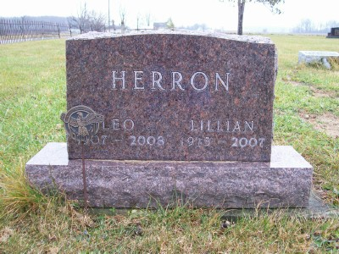
Photo by Scott Shoup

LILLIAN D. HERRON, 92, of Bluffton, passed away Friday, Dec. 21, 2007. Arrangements by Goodwin Memorial Chapel, 3220 E. SR 124, Bluffton.

News-Sentinel, The (Fort Wayne, IN) - Sunday, December 23, 2007

Contributed by Jane Edson
*****
Indiana, Death Certificates, 1899-2011
Name: Lillian D Herron [Lillian D Ripple]
Gender: Female; Race: White; Age: 92; Marital Status: Married
Birth Date: 11 Dec 1915; Birth Place: Wells
Death Date: 21 Dec 2007; Death Place: Markle, Wells, Indiana, USA
Father: Augustus Ripple; Mother: Lovina Dunbar; Spouse: Leo Herron
Informant: Larry Herron, son, Roanoke, IN
Burial: 12/24/2007, Bethel Cemetery

