Leo E. Herron
September 10, 1907 – February 7, 2008

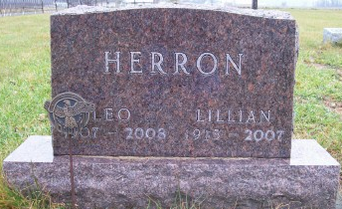
Photo by Scott Shoup

Leo E. Herron, 100, of Markle, died at 1:50 a.m. Thursday, Feb. 7, 2008, at Markle Health Care in Markle. Born in Shelby County to Howard and Mary (Reed) Herron on Sept. 10, 1907, he married Lillian D. Ripple in Bluffton on July 4, 1938; she preceded him in death on Dec. 21, 2007.
Mr. Herron served in the U.S. Army during World War II, from June 1943 to November 1945, and was a member of American Legion Post III for over 60 years. He worked for S.S. Kresge Co. for over 20 years, retiring in 1972, and also worked as a farmer and a truck driver. He was a member of Murray Missionary Church and the Civilian Conservation Club in Bluffton.
Surviving relatives include one son, Larry Herron of Roanoke; three grandchildren and four great-grandchildren.
Funeral services will be at 2 p.m. Saturday, at the Goodwin Memorial Chapel in Bluffton, with Pastor Troy Mower officiating. Calling hours will be from noon to 2 p.m. Saturday at the funeral home.
Burial is at Bethel Cemetery, in rural Bluffton.
Preferred memorials are to the Family Hospice of Northeast Indiana.

Bluffton News-Banner, Wells County, IN; February 7, 2008

