Elisa (Hall) Henley
May 10, 1811 – March 28, 1853

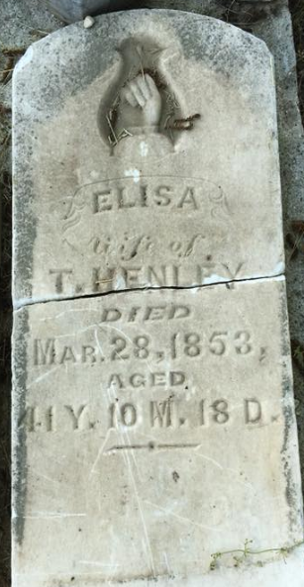
Photo by Scott Shoup

Sarah Elisa Hall from tree Herndon-Saurborn Tangled Roots

Birth ` 10 May 1811 Virginia, USA
Marriage 5 Nov 1832 Albemarle, Virginia, USA
Residence 1850 Wells, Indiana, USA
Death 28 Mar 1853 Wells, Indiana, USA
Father Nathan Hall (Born 1780)
Mother Jemima Scott (1790-1860)
Spouse Thompson Osborne Henley (1794-1876)
74682 People 4 Records 8 Sources
**

Land Atlas for Wells County, Indiana 1880-1881 - Historical figures
abstracted from article on John Henley

John Henley is a son of Thompson & Eliza (Hall) Henley, who removed from Virginia to Wells county in 1837.

