John L. Helms
January 10, 1865 – July 7, 1917

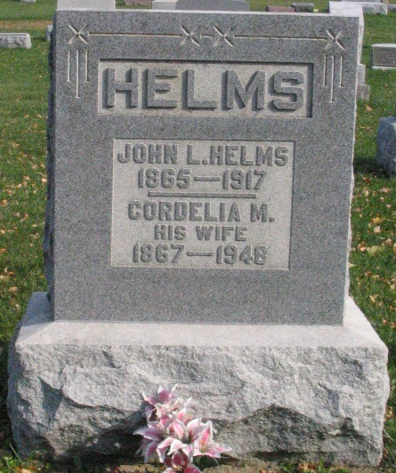
Photo by Barbara Baker Anderson

John L. Helms
in the Indiana, U.S., Death Certificates, 1899-2017

Name John L. Helms
Gender Male
Race White
Marital Status Married
Age 52
Birth Date 10 Jan 1865
Birth Place Wells County, Indiana
Death Date 7 Jul 1917
Death Place Lancaster, Wells, Indiana, USA
Death Registration Date 1917
Father Finley Helms
Mother Katherine Moyer
Spouse Cordelia Ratliff
Informant Family; Bluffton, Indiana
Burial July 9, 1917; Bethel Cemetery

