Cordelia May (Ratliff) Helms
March 30, 1867 – February 26, 1948

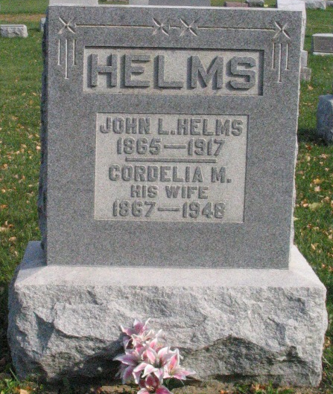
Photo by Barbara Baker Anderson

Cordella Helms
in the Indiana, U.S., Death Certificates, 1899-2017

Name Cordelia Helms
[Cordelia Ratliff]
Gender Female
Race White
Marital Status Widow
Age 80
Birth Date 30 Mar 1867
Birth Place Wells County
Death Date 26 Feb 1948
Death Place Rural, Wells, Indiana, USA
Death Registration Date 1948
Father Daniel Ratliff
Mother Harriett Hopkins
Spouse John Helms
Informant Mrs. Huston Surbaugh; Liberty Center, Indiana
Burial February 28, 1948; Bethel Cemetery; Wells County, Indiana

