Sophia (Kirkwood) Hedges
March 28, 1823 – August 27, 1870

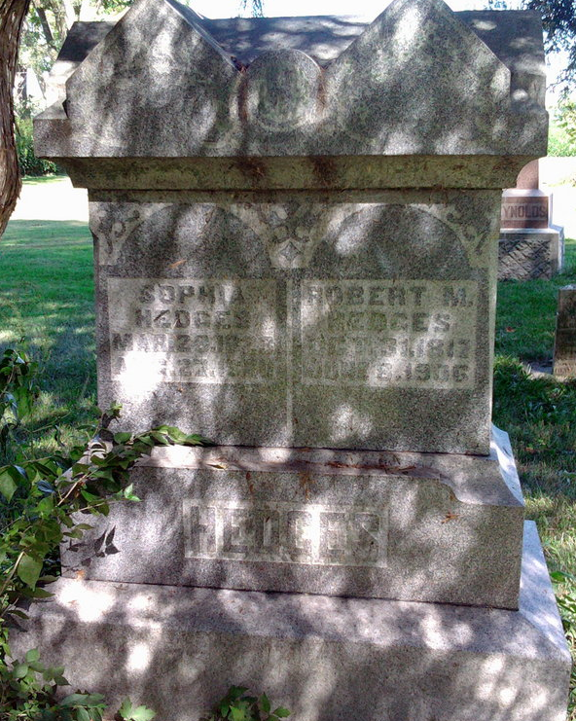
Photo by Thomas Liby

Sophia Kirkwood from tree STARR and HOLLOWAY Families

Birth 28 Mar 1823 Franklin, Beaver, Pennsylvania, USA
Marriage 22 Oct 1840 Fairfield, Madison, Ohio, USA
Residence 1870 Wells, Indiana, USA
Death 27 Aug 1870 Wells, Indiana, USA
Father William Kirkwood (1789-1824)
Mother Sophia Goshert/Cochet (1782-1872)
Spouse Robert McClure Hedges (1817-1906)
29628 People 20 Records 28 Sources
**

Ohio, U.S., County Marriage Records, 1774-1993

Name Sophia Kirkwood
Gender Female
Marriage Date 22 Oct 1840
Marriage Place Fairfield, Ohio, USA
Spouse Mcclure Hedges
Film Number 000295269
**

U.S., Family History Books

Name Sophia Kirkwood
Gender Female
Birth Date Mar 18, 1823
Birth Place Franklin County, Pennsylvania
Marriage Date Oct 1840; Marriage Place Fairfield Co., OH
Death Date Aug 27, 1870
Death Place Wells County, Indiana
Buried Bluffton, Wells, Ind.
Spouse Robert McClure Hedges
Child Mary J, Lucinda, Jonas T, Rebecca Ann, James Kirkwood
Title Hedges, p. 13 by White, F. Dale (Frederick Dale), 1913-

