James K. Hedges
October 25, 1849 – June 17, 1933

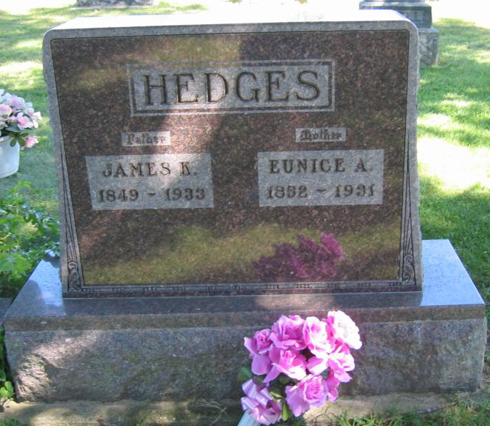
Photo by Tombstoner & Family

James R Hedges
in the Indiana, U.S., Death Certificates, 1899-2017

Name James R Hedges
Gender Male
Race White
Marital Status Widower
Age 83
Birth Date 25 Oct 1849
Birth Place Wells County, Indiana
Death Date 17 Jun 1933
Death Place Harrison, Wells, Indiana, USA
Death Registration Date 1933
Father Robt M Hedges
Mother Sophia Kirkwood
Spouse Eunice A Neff
Informant Arthur Hedges; Bluffton, Indiana
Burial June 19, 1933; Bethel Cemetery

