Harry Hedges
April 3, 1885 – November 15, 1977

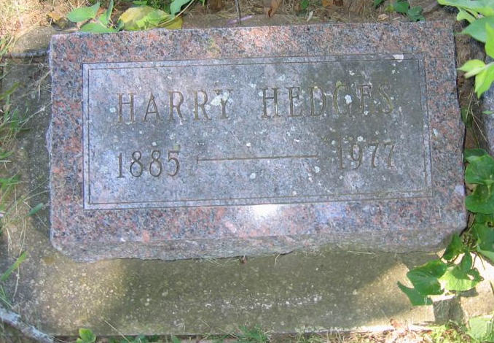
Photo by Tombstoner & Family

Harry Hedges
in the Indiana, U.S., Death Certificates, 1899-2017

Name Harry Hedges
Gender Male
Race White
Marital Status Divorced
Age 92
Birth Date 3 Apr 1885
Birth Place Indiana
Death Date 15 Nov 1977
Death Place Bluffton, Wells, Indiana, USA
Death Registration Date 1977
Father James K. Hedges
Mother Eunice Ann Neff
Informant None listed
Burial November 17, 1977; Bethel Cemetery; Wells County, Indiana

