Eunice Ann (Neff) Hedges
January 3, 1852 – May 21, 1931

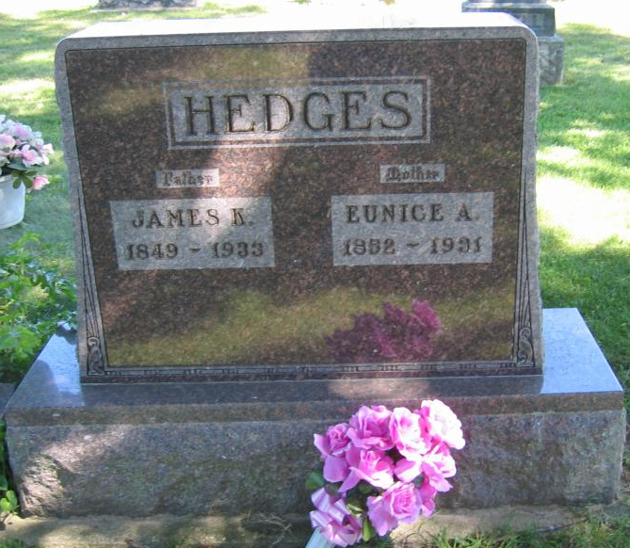
Photo by Tombstoner & Family

Emmie Ann Hedges
in the Indiana, U.S., Death Certificates, 1899-2017

Name Eunice Ann Hedges
Gender Female
Race White
Marital Status Married
Age 79
Birth Date 3 Jan 1852
Birth Place Athens County, Ohio
Death Date 21 May 1931
Death Place Harrison, Wells, Indiana, USA
Death Registration Date 1931
Father Levi Neff
Mother Rebbeca Goodspeed
Spouse James K Hedges
Informant Frank Hedges; Bluffton, Indiana
Burial March 23, 1931; Bethel Cemetery

