Patrick J. Harris
March 17, 1950 – April 21, 2019

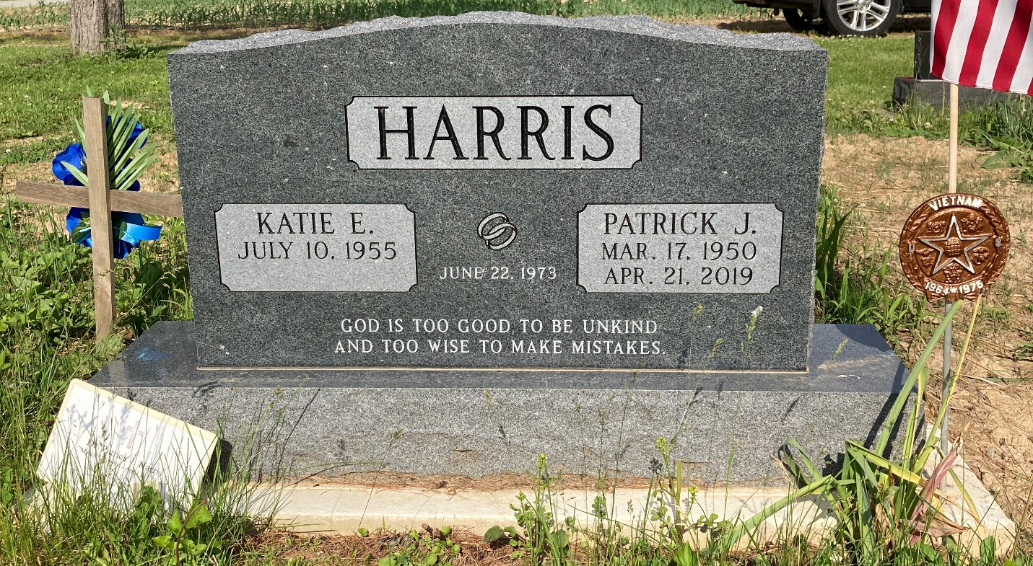
Photo by Scott Shoup

Dr. Patrick J. Harris, 69, of Convoy, Ohio passed away Sunday morning, April 21, 2019 at his residence following a brief illness.
He was born on March 17, 1950 in Marysville, Kansas to William A. and Bernice Lucille (Lewis) Harris. On June 22, 1973, he married Katie Elizabeth O’Neal in San Diego, California.
Pat served his country in the United States Army from 1970 to 1972.
He received his associate’s degree from San Diego State and his bachelor’s degree from National University in San Diego. His master’s and doctorate were both from Grace Theological Seminary in Winona Lake, Indiana. He served at Bethel Church in Bluffton, Indiana from 1985 to 2011. After moving to Alabama to be with family, he pastored Sardis Church in Hartford, Alabama and then from 2017 to 2018 he served as a chaplain at Valley Baptist Hospital in Harlingen, Texas. Following his chaplaincy, he served at Pleasant View Church in Van Wert County, Ohio.
Pat’s ministry started at Bethel Church in Bluffton where he spent 26 years pastoring, teaching, & discipling the church. Pat also made a huge impact on the Bluffton community. Throughout his ministry, he was very involved with Pro-Life causes and spent a lifetime of supporting Biblical values in the political arena. His heart for missions is most captured by the time he spent in Nepal. While in Nepal, he helped to start numerous churches, supported three orphanages, and trained new pastors. Pat “adopted” and financially supported a family of four orphans in Nepal. He just returned from his 18th trip to Nepal three weeks ago. Pat ended his earthly ministry serving and loving the people at Pleasant View Church alongside his lifelong friend, Jeff Millay.
Perhaps his greatest achievement in his life was being a wonderful husband, father, & grandfather to his wife, Katie of Convoy; three daughters, Christina (Richard) Schleyer of Hickory, NC, Stephanie (Daniel) Acuna of Camp Lejeune, NC, & Jessica (Michael) Myers of Offutt AFB, NE; sister, Judy (Jerry) Tetley of Hemet, CA; brother, Mike (Joann) Harris of Branson, MO; & seven grandchildren, Isabella Schleyer, Katie Myers, Tommy Schleyer, Jackson Myers, David Acuna, Daniel Acuna, & James Myers. He was preceded in death by his parents and two brothers, David and Gary Harris.
A funeral service will be held at 11:00 a.m. Thursday, April 25, 2019, at Pleasant View Church located at 12008 State Route 49, Ohio City, Ohio with Pastor Jeff Millay officiating. Family and friends will be received from 9 a.m. until the time of the funeral service at the church. Military Graveside Honors will be conducted by the American Legion Post #43 of Decatur at 3:00 p.m. Thursday, April 25, 2019 at Bethel Church Cemetery in Bluffton, Indiana.
In lieu of flowers, the family requests memorials be made to The Pat Harris Memorial Fund in Nepal (Checks can be mailed to Zwick & Jahn Funeral Home, 520 N 2nd St, Decatur, IN 46733).

Zwick & Jahn Funeral Home, Adams County, IN
April 24, 2019

