Edith (Sickler) Harris-Mowery
May 31, 1889 – July 24, 1973

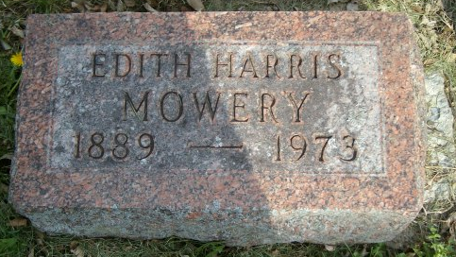
Photo by smalltown

Edith Mowery
in the Indiana, U.S., Death Certificates, 1899-2017

Name Edith Mowery
[Edith Sickler]
Gender Female
Race White
Marital Status Widowed
Age 84
Birth Date 31 May 1889
Birth Place Missouri
Death Date 24 Jul 1973
Death Place Columbia, Whitley, Indiana, USA
Death Registration Date 1973
Father George Sickler
Mother Louisa Smith
Spouse # 1 - Harris; # 2 - Mowery
Informant Gail Harris; son; Columbia City, Indiana
Burial July 27, 1973; Bethel Cemetery; Wells County, Indiana

