Earl Ray Harris
November 3, 1888 – January 7, 1948

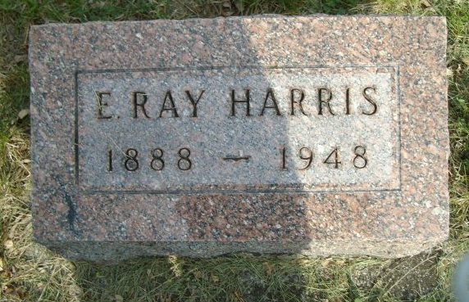
Photo by smalltown

Earl Ray Harris
in the Indiana, U.S., Death Certificates, 1899-2017

Name Earl Ray Harris
Gender Male
Race White
Marital Status Married
Age 59
Birth Date 3 Nov 1888
Birth Place Farmland, Indiana
Death Date 7 Jan 1948
Death Place Fort Wayne, Allen, Indiana, USA
Death Registration Date 1948
Father Ora A Harris
Mother Lucinda Baldwin
Spouse Edith
Informant Carl Harris
Burial January 10, 1948; Bethel Cemetery; Bethel, Indiana

