Rachel (Webb) Griffin
July 9, 1786 – April 20, 1860

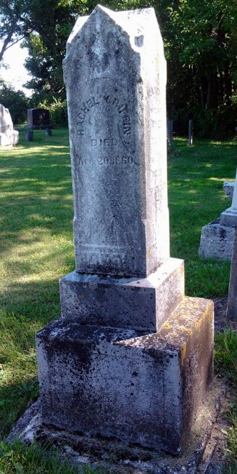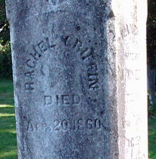
Photo by Thomas Libby

Rachael Webb from tree Sherman-Baker Tree

Birth 9 Jul 1786 Bridgeport, Harrison, West Virginia, USA
Marriage 12 Sep 1805 Harrison, West Virginia, USA
Residence 1850 Wells, Indiana, USA
Death 20 Apr 1860 Bluffton, Wells, Indiana, USA
Father Benjamin Webb (1761-1826)
Mother Elizabeth Nixon (1765-1822)
Spouse Henry S. Griffin (1783-1844)
5285 People 8 Records 9 Sources
**

West Virginia, U.S., Marriages Index, 1785-1971

Name Rachel Webb
Gender Female
Spouse's Name Henry Griffin
Spouse Gender Male
Marriage Date 12 Sep 1805
Marriage Place Harrison County, West Virginia

