Arta Griffin
August 13, 1882 – June 19, 1883

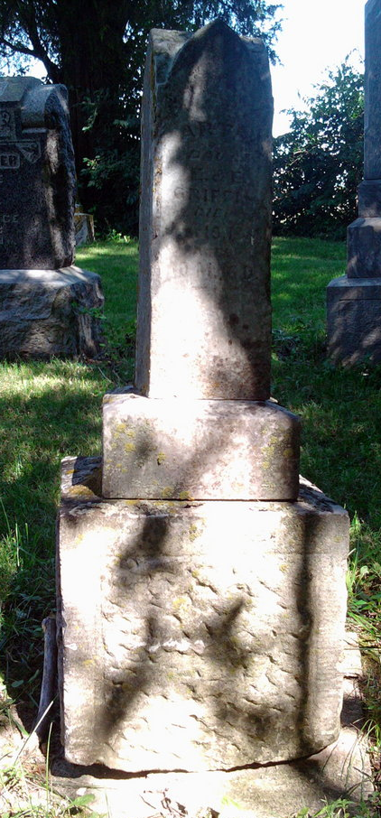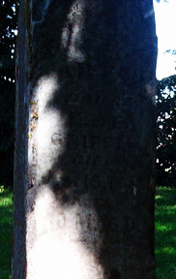
Photo by Thomas Libby

No further information found at this time.

