Juliana Gracy
1842 – January 7, 1860

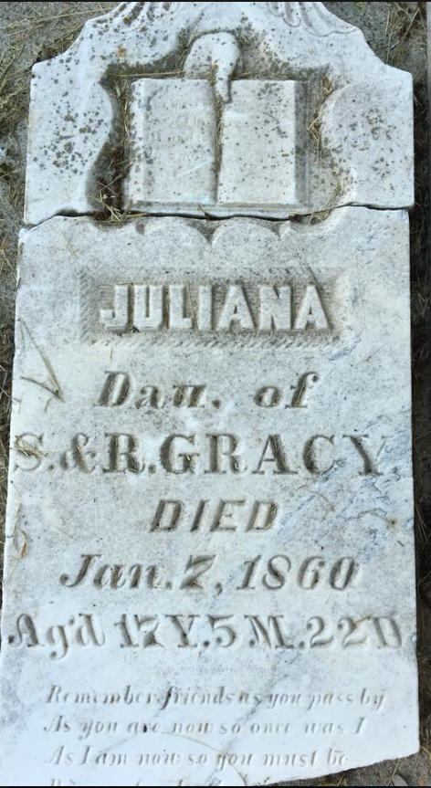
Photo by Scott Shoup

Juliana Gracy from tree C Randolph Family Tree

Birth 1842 Fayette, Fulton, Ohio, USA
Residence 1850 Wells, Indiana, USA
Death 7 Jan 1860 Wells, Indiana, USA
Father Samuel Gracy (1797-1877)
Mother Rachael Snively (1800-1865)
3455 People 1 Record 3 Sources

