Katherine “Kate” (McDowell) Flynn
February 11, 1855 – September e, 1949

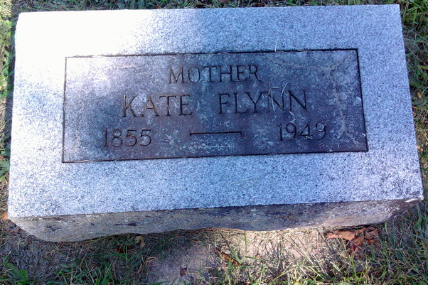
Photo by Thomas Liby

Katherine Flynn
in the Indiana, U.S., Death Certificates, 1899-2017

Name Katherine Flynn
[Katherine McDowell]
Gender Female
Race White
Marital Status Widowed
Age 94
Birth Date 11 Feb 1855
Birth Place Wells County, Indiana
Death Date 3 Sep 1949
Death Place Bluffton, Wells, Indiana, USA
Death Registration Date 1949
Father George McDowell
Mother Eliza Henning
Informant Eugene A. Tappy; Chicago, Illinois
Burial September 5, 1949; Bethel Cemetery; Wells County, Indiana

