Lucinda “Cindy” Fenton
February 15, 1905 – June 15, 1994

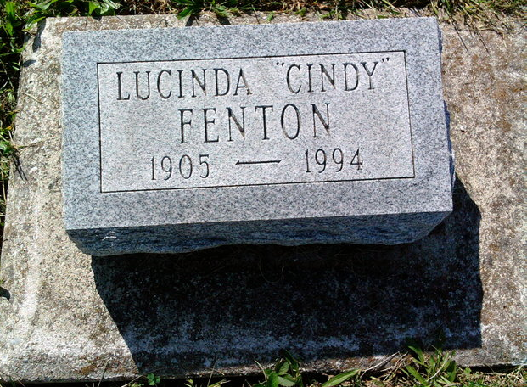
Photo by Thomas Liby

Lucinda Fenton
in the Indiana, U.S., Death Certificates, 1899-2017

Name Lucinda Fenton
Gender Female
Race White
Marital Status Single
Age 89
Birth Date 15 Feb 1905
Birth Place Bentontowne, Indiana
Death Date 15 Jun 1994
Death Place Bluffton, Wells, Indiana, USA
Death Registration Date 1994
Father Enis Fenton
Mother Etta Clark
Informant Loretta Inman; friend; Bluffton, Indiana
Burial June 20, 1994; Bethel Cemetery; Bluffton, Indiana

