Frances Farr
April 16, 1892 – August 27, 1892

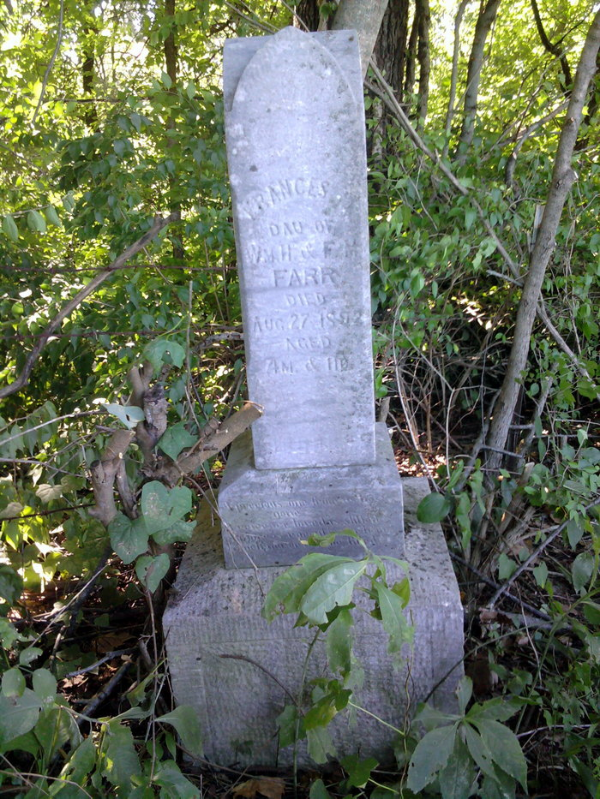
Photo by Thomas Liby

No further information found at this time.

