Frances Farr
1856 – October 2, 1894

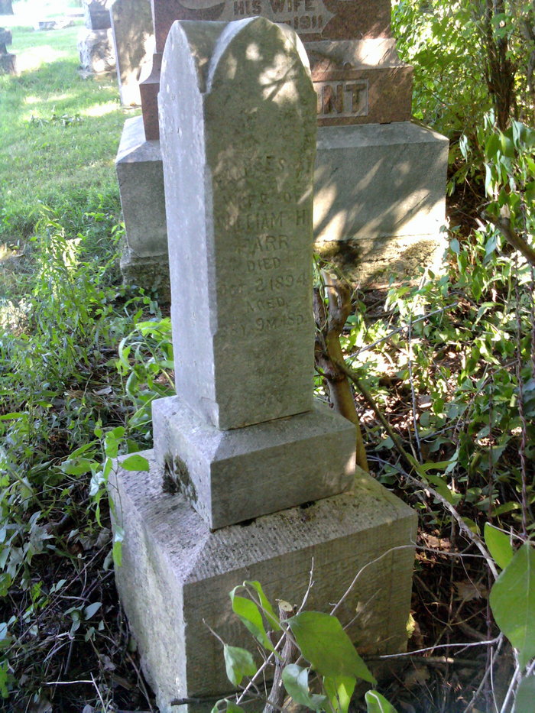
Photo by Thomas Liby

No further information found at this time.

