Charles B. Evans
November 5, 1822 – November 7, 1898

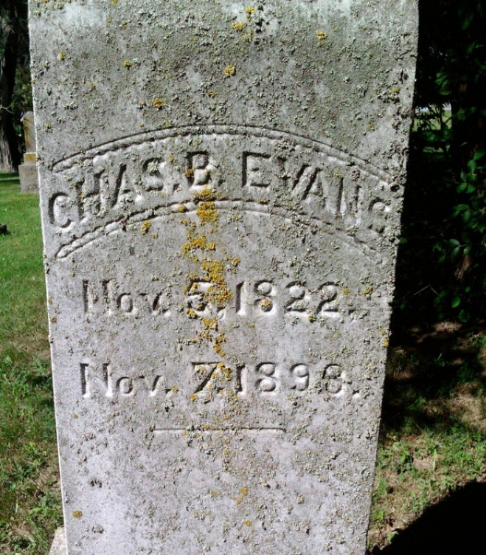
Photo by Thomas Liby

Charles B Evans from tree Matthews Family Tree

Birth 5 Nov 1822 Pennsylvania, USA
Marriage 22 Apr 1848 Montgomery, Ashland, Ohio, USA
Residence 1860 Wells, Indiana, USA
Death 7 Nov 1898 Wells, Indiana, USA
Father Francis Evans (1800-1868)
Mother Margaret Maginnitt (Born 1800)
Spouse Anna Maria Schaeffer (1829-1875)
57395 People 3 Records 4 Sources
**

Ohio, U.S., County Marriage Records, 1774-1993

Name Charles B. Evans
Gender Male
Marriage Age 21
Birth Date abt 1827
Marriage Date 22 Apr 1848
Marriage Place Montgomery, Ohio, USA
Spouse Anna Maria Schaeffer
Film Number 001030835

