Max L. Edris
May 5, 1946 – October 26, 2011
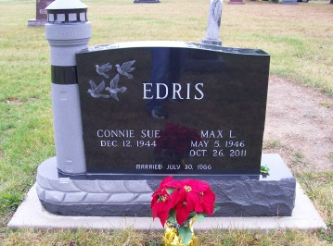
Photo by Scott Shoup

Max L. Edris, 65, of Bluffton, died at 5:30 a.m. Wednesday, Oct. 26, 2011 at his residence.
Max was born on May 5, 1946, in Bluffton, to Lawrence and Dorothy (Boone) Edris. He married Connie S. Davis on July 30, 1966 in Petroleum; she survives.
A 1964 graduate of Rockcreek High School, Max worked for Rice Oldsmobile in Waynedale for 10 years, Reimschisel Ford for nine years, and retired as a mechanic from Southern Wells Community Schools after 22 years. He attended Sonlight Wesleyan Church. Max enjoyed working on cars, drag racing at Muncie Drag Strip, flying R.C. airplanes, and spending time with his family and friends.
Other surviving relatives include one daughter, Kahlia "Kelly" Peterson of Bluffton; one son, Todd (Shelly) Edris of Bluffton; one sister, Judy (Chad) Garrett of Braggs, Okla.; two brothers, Larry (Sherry) Edris of Fennville, Mich., and Gerald (Cheryl) Edris of Marion; two grandsons, Tyler Peterson and Colton Edris; and special relatives, Dave and Janet Baller of Fort Wayne.
Calling hours will be from 1 to 7 p.m. Friday, Oct. 28, at the Goodwin Memorial Chapel in Bluffton. Funeral services will be at 7 p.m. Friday, at the funeral home with Pastor Tom Bradley officiating. Private burial will be at Bethel Cemetery on Saturday, Oct. 29.
Preferred memorials are to the Family Hospice and Palliative Care or the American Kidney Foundation.
Online condolences: www.thegmcfamily.com.

Bluffton News-Banner, The (IN) - Thursday, October 27, 2011

Contributed by Jane Edson

