Lewis Cass Dunbar
June 4, 1848 – October 11, 1922

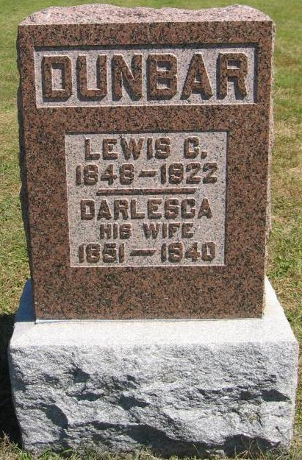
Photo by Tombstoner & Family

Former Adams County Resident Died Today

Lewis Cass Dunbar, 74, formerly of Adams County, died at 10 o'clock this morning at his home on East Ohio Street in Bluffton, following a short illness with lock-jaw. About a week ago, Mr. Dunbar stepped on a rusty nail which penetrated his foot. The injury caused lock-jaw. The deceased lived in Adams County until ten years ago, when he moved to Bluffton. The following brothers survive: L. L. and Jefferson Dunbar, of Linn Grove; Byron Dunbar, of White Water, Wis., and Lorenzo Dunbar, of Indianapolis. Mrs. Lavina Riple, of Bluffton, is a daughter. Funeral arrangements have not been made.

Decatur Daily Democrat, Adams County, Indiana
Wednesday, October 11, 1922
**

Indiana, U.S., Death Certificates, 1899-2017

Name Lewis Cass Dunbar
Gender Male
Race White
Marital Status Married
Age 74
Birth Date 4 Jun 1848
Birth Place Adams County, Indiana
Death Date 11 Oct 1922
Death Place Bluffton, Wells, Indiana, USA
Father Lucian Dunbar
Mother Philena Leuch??
Spouse Darlisco Shepperd
Informant Mrs. L. C. Dunbar; Bluffton, Indiana
Burial October 13, 1922; Bethel Cemetery

