Amanda Ellen (Roberts) Devilbiss
December 31, 1861 – March 15, 1935

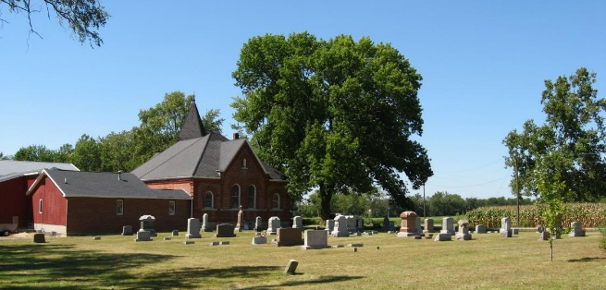
Photo by Tombstoner & Family

Amanda Ellen Devilliers
in the Indiana, U.S., Death Certificates, 1899-2017

Name Amanda Ellen Divelbus
[Amanda Ellen Roberts]
Gender Female
Race White
Marital Status Married
Age 73
Birth Date 31 Dec 1861
Birth Place Huntington County, Indiana
Death Date 15 Mar 1935
Death Place Bluffton, Wells, Indiana, USA
Father William Roberts
Mother Eliza Jane Earhart
Spouse Wm T Devilbiss
Informant Wm. T. Devilbiss; Huntington, Indiana
Burial Mach 18, 1935; Bethel Cemetery; Wells County, Indiana
**

Indiana, U.S., Marriages, 1810-2001

Name Amanda Brinneman
[Amanda Roberts]
Gender Female
Race White
Age 71
Birth Date 31 Dec 1861
Birth Place Huntington, Indiana
Marriage Date 26 Mar 1932
Marriage Place Indiana, United States
Residence Place Bluffton, Indiana
Father William Roberts
Mother Eliza Earhart
Spouse William F Divelbiss
Page 457
FHL Film Number 002318466

