Decator DeWitt
January 10, 1826 – December 13, 1909

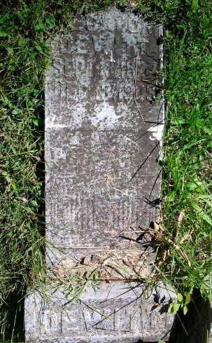
Photo by Thomas Liby

Decator De Witt
in the Indiana, Death Certificates, 1899-2011
Name: Decator De Witt
Gender: Male
Race: White
Age: 83
Marital status: Divorced
Birth Date: 10 Jan 1826
Birth Place: Ohio
Death Date: 13 Dec 1909
Death Place: Bluffton, Wells, Indiana , USA
Father: Gabrel De Witt
Mother: Racheal
Spouse: Isabell Reynolds
Informant: J. M. DeWitt; Blutton, Ind.
Burial: Dec. 15, 1909; Bethel Cem.

