Gene A. Cook
November 13, 1948 -

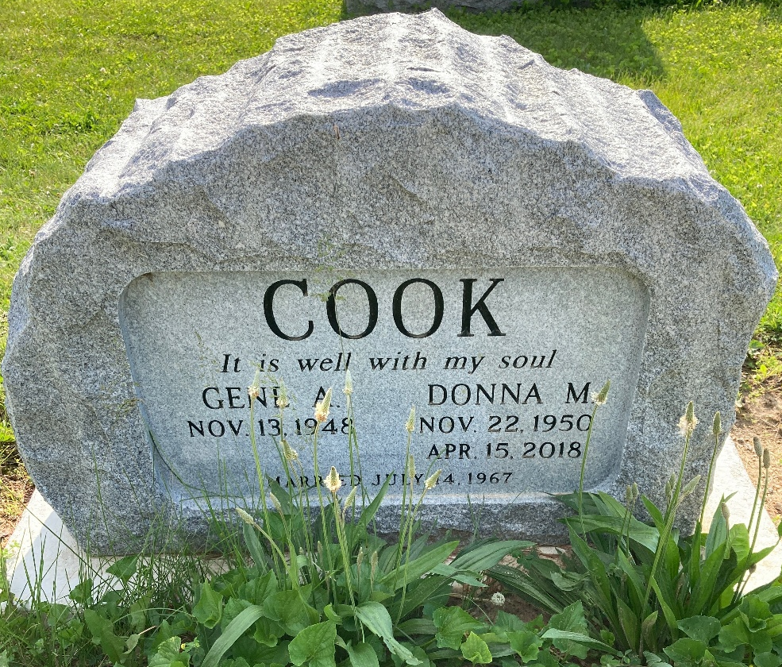
Photo by Scott Shoup

