Donna M. (Zion) Cook
November 22, 1950 – April 15, 2018

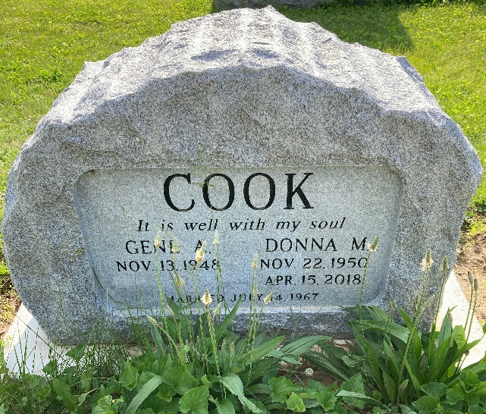
Photo by Scott Shoup

Donna M. Cook, 67, of Liberty Center, passed away Sunday evening, Apr. 15, 2018, at her residence. Born in Ft. Wayne, IN, on Nov. 22, 1950, to George and Thelda (Phillips) Zion, Donna married Gene A. Cook in Yoder, IN, on July 14, 1967; he survives.
Donna was a member of Bethel Church. 1 Corinthians 13: 4-8 - Love is patient, love is kind and is not jealous; love does not brag and is not arrogant, does not act unbecomingly; it does not seek its own, is not provoked, does not take into account a wrong suffered, does not rejoice in unrighteousness, but rejoices with the truth; bears all things, believes all things, hopes all things, endures all things. Love never fails; but if there are gifts of prophecy, they will be done away; if there are tongues, they will cease; if there is knowledge, it will be done away.
In addition to her husband, Donna is survived by a son, Carl (Toni) Cook of Uniondale; a daughter, Janelle Steffen of Bluffton; three grandchildren, Carissa, Ayden, and Jake Steffen; a great-granddaughter, Penelope Pavlin; two brothers, Kenny (Jo) Zion of Matthews, N.C., and Kevin (Heather) Zion of Ft. Wayne; along with a grandson, and one on the way in July.
Aside from her parents, Donna was preceded in death by her son-in-law, Sam Steffen; and infant brother, David Zion.
Visitation will be Wednesday, Apr. 18, 2018, from 2:00 until 8:00 PM, at Goodwin- Cale & Harnish Memorial Chapel in Bluffton. Services will be held on Thursday, Apr. 19, 2018, at 11:00 AM, at the funeral home, with one hour of visitation prior to the service. Pastor Ron Garner will officiate. Burial will follow at Bethel Cemetery in Bluffton. Per the request of the family, in lieu of flowers, memorial contributions may be made to Compassion International or Bethel Church.

Goodwin-Cale & Harnish Funeral Homes, Wells County, Indiana April 16, 2018

