Mary L. Conrad
1854 – November 14, 1859

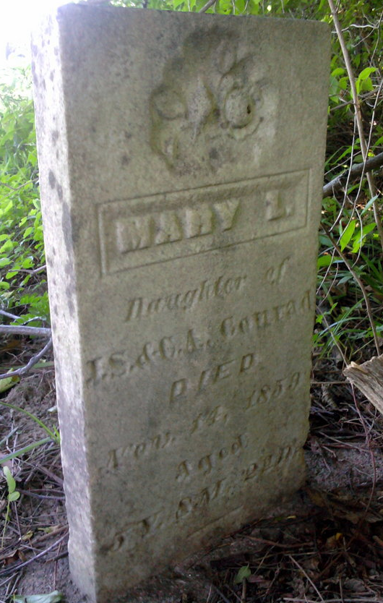
Photo by Thomas Liby

Mary L. Conrad from tree Armantrout Family Tree

Birth 1854
Death 14 Nov 1859 Bluffton, Wells, Indiana, USA
Father John S. Conrad (1807-1900)
Mother Cloann May (1817-1906)
1460 People 0 Records 1 Source

