George A. Conrad
July 2, 1860 – August 18, 1910

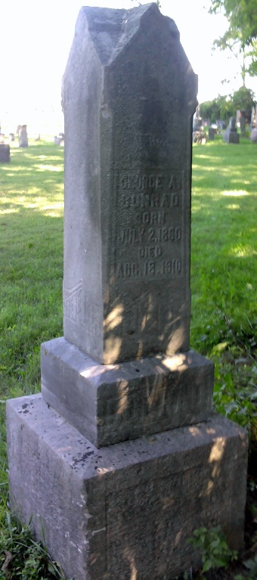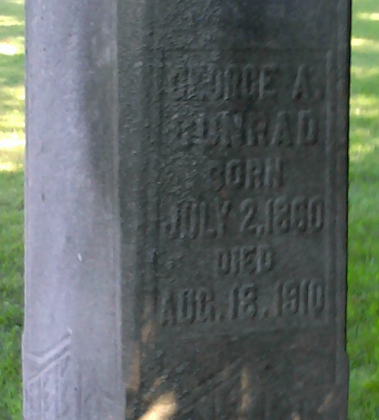
Photo by Thomas Liby

Michigan, U.S., Death Records, 1867-1952

Name Geo Conrad
Gender Male
Race White
Marital Status Married
Death Age 50y 1m 16d
Age 42
Birth Date 2 Jul 1860
Birth Place Indiana
Death Date 18 Aug 1910
Death Place Texas, Kalamazoo, Michigan, USA
Father John S Conrad
Mother Chloe A May
Informant John Beam, Bluffton, Wells, IN
**

Indiana, U.S., Marriage Index, 1800-1941

Name George A Conrad
Marriage Date 22 Sep 1887
Marriage Place Adams, Indiana, USA
Spouse Name Amanda O Sheperd

