Lewis H. Colbert
December 13, 1857 – July 4, 1942

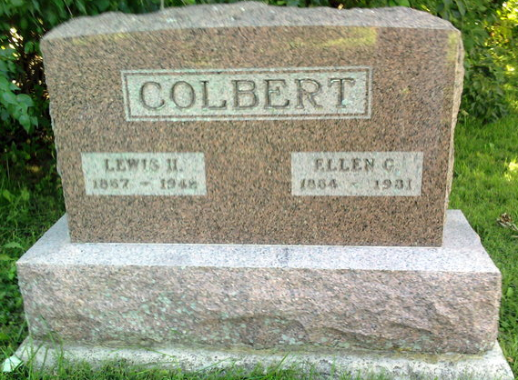
Photo by Thomas Liby

Lewis H Colbert
in the Indiana, U.S., Death Certificates, 1899-2017

Name Lewis H Colbert
Gender Male
Race White
Marital Status Widowed
Age 84
Birth Date 13 Dec 1857
Birth Place Jackson Tp., Wells County
Death Date 4 Jul 1942
Death Place Bluffton, Wells, Indiana, USA
Death Registration Date 1942
Parents Unknown
Spouse Eliza C. Wolf
Informant Donald Colbert; Poneto, Indiana
Burial July 7, 1942; Bethel Cemetery; Bluffton, Indiana
**

lewis h. colbert from tree bowman family tree

Birth 18 Dec 1857 Wells, Indiana, USA
Marriage 16 Feb 1878 Wells, Indiana, USA
Residence 1930 Wells, Indiana, USA
Death 5 Jul 1942 Bluffton, Wells, Indiana, USA
Father lewis h. colbert (1832-1857)
Mother esther batson (1834-1897)
Spouse eliza wolf
5695 People 13 Records 21 Sources
**

Indiana, U.S., Marriage Certificates, 1960-2012

Name Lewis H Colbert
Gender Male
Marriage License Date 16 Feb 1878
Marriage Date 17 Feb 1878
Marriage Place Wells, Indiana, USA
Spouse Ellen G Shepherd
Officiator J Wesley Paschall

