Lemuel S. Colbert
June 19, 1881 – September 24, 1931

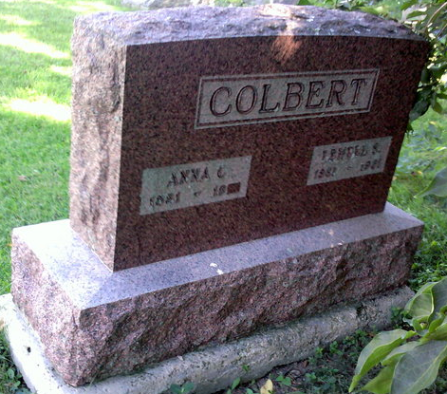
Photo by Thomas Liby

Lemual Colbert Succumbs

Lemual Colbert, 50, retired poolroom owner, died suddenly of a heart attack last night at his home at 3030 East Central avenue, this city. Surviving are the widow; the father, and two sons, Homber B. Colbert, of Fort Wayne, and Donald B. Colbert. Mr. Colbert was an active member of the Bluffton Lodge of Moose. Funeral services will be held at the Bethel M. E. Church at 2 o’clock Sunday afternoon in charge of the Rev. H. E. Circuit, assisted by the Rev. Matthew Worthman, of the Bluffton Reformed Church. Burial will be in the Bethel Cemetery.

The Star Press, Muncie, Indiana
Saturday, September 26, 1931
**

Indiana, U.S., Death Certificates, 1899-2017

Name Lemuel S Colbert
Gender Male
Race White
Marital Status Married
Age 50
Birth Date 19 Jun 1881
Birth Place Harrison Wp Wells Co., Indiana
Death Date 24 Sep 1931
Death Place Bluffton, Wells, Indiana, USA
Death Registration Date 1931
Father Lewis H Colbert
Mother Ellen Sheppard
Spouse Anna C. Beckler
Informant Mrs. L. S. Colbert; Bluffton, Indiana
Burial September 27, 1931; Bethel Cemetery

