Ellen G. (Shepherd) Colbert
August 26, 1854 – July 9, 1931

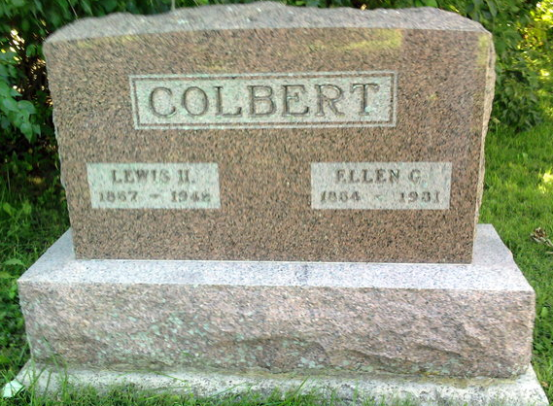
Photo by Thomas Liby

Ellen G Colbert
in the Indiana, U.S., Death Certificates, 1899-2017

Name Ellen G Colbert
[Ellen G Sheppard]
Gender Female
Race White
Marital Status Married
Age 76
Birth Date 26 Aug 1854
Birth Place Wells
Death Date 9 Jul 1931
Death Place Harrison, Wells, Indiana, USA
Death Registration Date 1931
Father Harrison Sheppard
Mother Elizabeth Ricketts
Spouse Lewis Colbert
Informant Lewis Colbert; Bluffton, Indiana
Burial July 11, 1931; Bethel Cemetery

