Anna Louise Colbert
March 28, 1931 – February 1, 1938

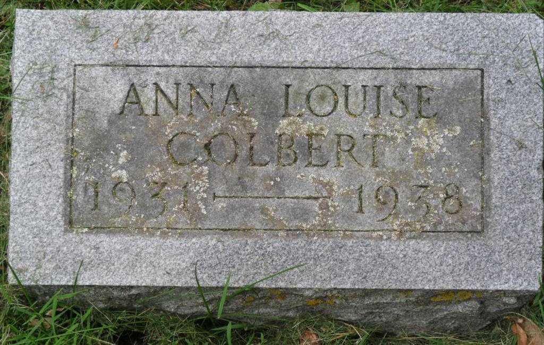
Photo by Pretty Little Grave Seekers

Anna Louise Colbert
in the Indiana, U.S., Death Certificates, 1899-2017

Name Anna Louise Colbert
Gender Female
Race White
Marital Status Single
Age 6
Birth Date 28 Mar 1931
Birth Place Chester Township, Wells County, Indiana
Death Date 1 Feb 1938
Death Place Chester, Wells, Indiana, USA
Death Registration Date 1938
Father Donald B Colbert
Mother Emma Abend
Informant Donald Colbert; Poneto, Indiana
Burial February 4, 1938; Bethel Cemetery

