Anna C. (Beckler) Colbert
January 29, 1881 – October 14, 1961

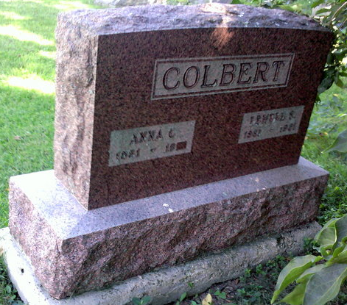
Photo by Thomas Liby

Indiana, U.S., Death Certificates, 1899-2017

Name Anna C Colbert
[Anna C Beckler]
Gender Female
Race White
Marital Status Widowed
Age 80
Birth Date 29 Jan 1881
Birth Place Indiana
Death Date 14 Oct 1961
Death Place Westville, LaPorte, Indiana, USA
Death Registration Date 1961
Father Benjamin Beckler
Mother Brodt
Informant Hospital records
Burial October 17, 1961; Bethel Cemetery; Wells County, Indiana

