Rachel Elizabeth (Burgess) Cobbum
October 4, 1833 – March 4, 1857

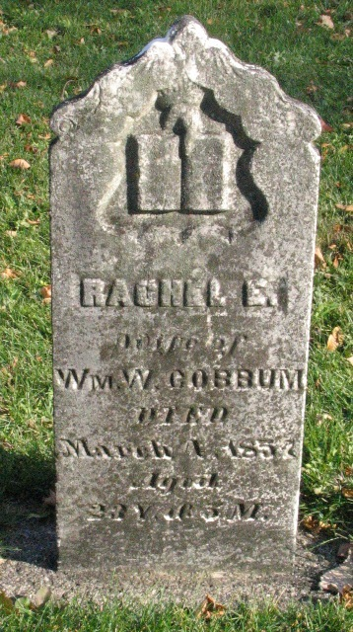
Photo by Barbara Baker Anderson

Web: Indiana, U.S., Marriage Index, 1806-1861

Name Rachel E Burgess
Marriage Date 23 Oct 1851
Marriage Place Wells, Indiana, USA
Spouse William W Cobbum
**

U.S., Family History Books

Name Miss Elizabeth Burgess
Gender Female
Marriage Date 1851
Death Date Mar 1857
Spouse Wm. W Cobbum
Title History of Elkhart County, Indiana, 1881, p. 931
Wm. W. Cobbum <snip> was married in 1851, to Miss Elizabeth Burgess, by whom he had 1 child, deceased. She died in March 1857, and he again married in 1861, this time Miss Urillah Shoup, daughter of David Shoup, of Lagrange county, Ind. <snip>
**

Rachel Elizabeth Burgess from tree Diard Family Tree

Birth 4 Oct 1833
Marriage 23 Oct 1851 Wells, Indiana, USA
Death 4 Mar 1857 Bluffton, Wells, Indiana, USA
Father John Burgess
Mother Sarah
Spouse William Wallace Cobbum (1827-1893)
4362 People 1 Record 3 Sources

