Lulu M. (Vore) Cobbum
January 14, 1880 – March 23, 1947

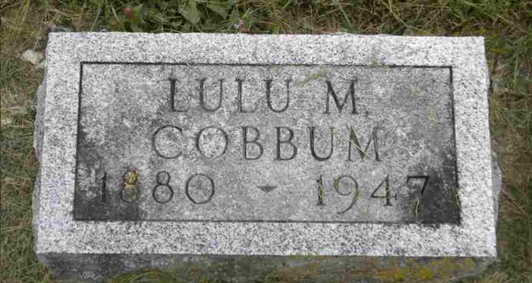
Photo by Pretty Little Grave Seekers

Lulu Cobbum
in the Indiana, U.S., Death Certificates, 1899-2017

Name Lulu Cobbum
[Lulu Vore]
Gender Female
Race White
Age 67
Birth Date 14 Jan 1880
Birth Place Wells County, Indiana
Death Date 23 Mar 1947
Death Place Rural, Wells, Indiana, USA
Death Registration Date 1947
Father Reynolds Vore
Mother Emma Fry
Spouse George Cobbum
Informant John Vore; Bluffton, Indiana
Burial March 23, 1947; Bethel Cemetery

