Lucy Ellen Cobbum
January 19, 1854 – February 12, 1854

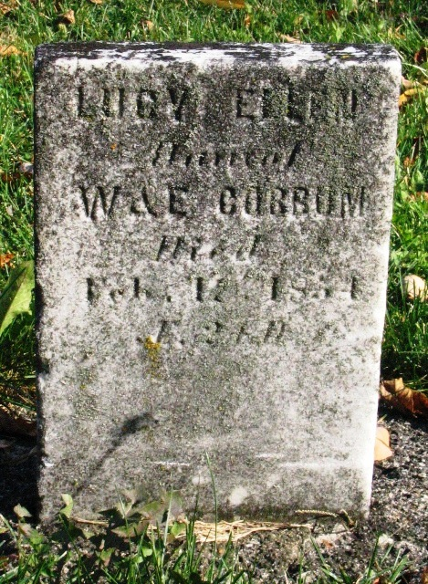
Photo by Barbara Baker Anderson

Lucy Ellen Cobbum from tree Miller Family Tree

Birth 19 Jan 1854
Death 12 Feb 1854
Father William Wallace Cobbum (1827-1893)
Mother Rachel Elizabeth Burgess (1834-1857)
5021 People 0 Records 0 Sources

