James Linton Cobbum Sr.
July 26, 1783 – February 15, 1861

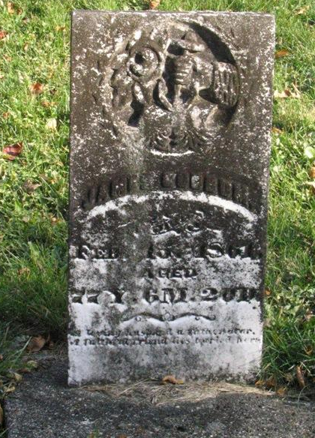
Photo by Barbara Baker Anderson

JAMES L. COBBUM
Another Wells County Pioneer Called Home

After a long and severe illness of typhoid fever, Jame L. Cobbum died at this home on South street last Friday afternoon, at the age of 59 years, 11 months and 27 days.
He was born in Hocking county, Ohio, Nov. 1st, 1834, and came to Wells county with his parents in 1836. The family encountered great hardships in getting here. It was before the time of railroads and they made their way here slowly by means of ox teams. The waters were very high and some parts of the journey were attended with great danger. James was but two years old and his mother rode horse back and carried him.
Thus he has been a citizen of the county for fifty-eight years. When he first saw this county it was a vast wilderness, and he was reared amid the hardships of a frontier life. October 13, 1861 he was married to Sarah E. Hasenphleugh. To this union were born five children, the oldest of whom, Charles, has already gone to the sprit land. His wife died about ten years ago.
Until nine years ago he lived on the farm he labored so hard to improve and beautify. He then moved to this city where he has since resided. For several years he has engaged in the sale of farm implements.
He has been a member of the Methodist church for several years, and during his long and painful sickness endured his sufferings patiently and had the assurance of eternal rest.
A son, three daughters and three grandchildren are left to mourn his departure. Three of his brothers, joseph W., Henry G. and Rufus R. survive him.
He was held in high esteem by all who knew him, and it is the general … (continued)
City. His funeral occurred Sunday afternoon at one o’clock. The remains were taken to the Bethel Methodist Episcopal church under the escort of the Odd Fellow lodge of this city, there being an unusually large representation of the order. The funeral was said to be the largest ever held in that part of the country, the procession reaching over a mile in Length. Not more than one-fourth of those present could get into the church. The sermon was preached by the Rev. C. U. Wade of this city.

The Bluffton Banner, Vol. XLV, # 15
Wednesday, November 7, 1894, p. 1, col. 5

