George T. Cobbum
June 19, 1880 – September 25, 1943

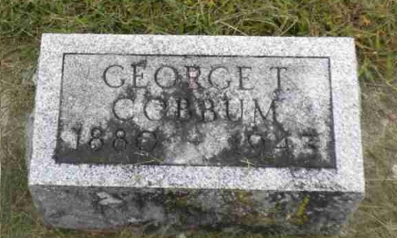
Photo by Pretty Little Grave Seekers

George J Cobbum
in the Indiana, U.S., Death Certificates, 1899-2017

Name George J Cobbum
Gender Male
Race White
Marital Status Married
Age 63
Birth Date 19 Jun 1880
Birth Place Wells County, Indiana
Death Date 25 Sep 1943
Death Place Bluffton, Wells, Indiana, USA
Death Registration Date 1943
Father Joseph Cobbum
Mother Sarah Chalfant
Spouse Lulu Vore; age 63
Informant Mrs. George Cobbum
Burial September 27, 1943; Bethel Cemetery; Wells County, Indiana

