Reason Chalfant
June 1, 1835 – April 2, 1915

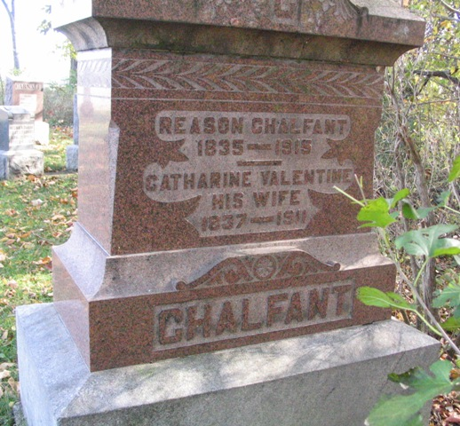
Photo by Barbara Baker Anderson

REASON CHALFANT PASSED AWAY FRIDAY.

Reason Chalfant, one of Wells County's esteemed pioneers, passed away at 12:45 o'clock this afternoon, at the home of his son, Abner Chalfant, 803 South Main Street. He had been sick since two weeks ago last Sunday, when he contracted grip. Complications developed, including gangrene, and for several days no hope had been enter-tained for his recovery.
Mr. Chalfant was born June 1, 1835, in Ohio, and would have been eighty years of age June first this year. He was only two or three years old when he was brought to this county by his parents, Mr. and Mrs. Chads Chalfant, early settlers south of Bluffton. He spent the entire remainder of his life, or about 75 years, in this county. He was united in marriage when a young man with Miss Catherine Valentine, who was from another pioneer family, and they lived happily together until her death, about five years ago.
Of our children born to them, three survive, Abner of this city, Robert D., living south of Bluffton, and Mrs. Alice Gentis, wife of Charles Gentis, also living south of Bluffton. Since the death of his wife, he had made his home with his children, coming to the home of the son in this city about six weeks ago.
The funeral will be held at the Bethel Methodist Episcopal Church Sunday afternoon at 2:30 o'clock, in charge of the Rev. W. T. Arnold of this city, and burial will be in the Bethel Cemetery.

Bluffton Chronicle, Wells County, Indiana
Wednesday, April 7, 1915
**

Reason Chalfant was a son of Chads and Nancy (Ferguson) Chalfant. Chads Chalfant, who was born at Chads Ford in Pennsylvania, moved in early life to Ohio, married in Perry County, and in 1837 came to Indiana and located in the wilderness of Wells County. He entered the southwest quarter of section 25 of Harrison Township, and thus acquired the land which later developed as a good farm was the scene of Abner Chalfant's birth and early rearing. Chads Chalfant was a man equal to all the emergencies and exigencies of pioneer life. He built a log cabin home and on his old farm he lived out the rest of his years. He died in February, 1883. He and his wife had the following children: Reason, Robert, Elizabeth, Lydia, Mercey, Mary and Sarah. After his marriage Reason Chalfant settled on the old homestead, and thus kept that land within the family ownership. He was an industrious and capable farmer but otherwise was quiet and unassuming, and sought none of the honors of public life. He voted as a republican. His children were: Abner, William, now deceased, Robert D. and Clara, wife of Charles Gentes.

Standard History of Adams and Wells Counties, Indiana, 1918

