Nathan M. “Nate” Chalfant
December 18, 1885 – October 24, 1907

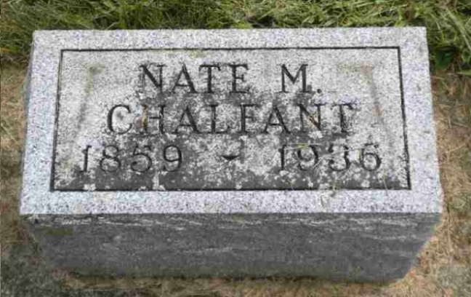
Photo by Pretty Little Grave Seekers

Nathan M Chalfant
in the Indiana, U.S., Death Certificates, 1899-2017

Name Nathan M Chalfant
Gender Male
Race White
Marital Status Widowed
Age 77
Birth Date 22 May 1859
Birth Place Indiana
Death Date 14 Jun 1936
Death Place Vera Cruz, Wells, Indiana, USA
Death Registration Date 1936
Father Robert Chalfant
Mother Mary Jane Melick
Spouse Martha Shuman
Informant Geo. Chalfant; Bluffton, Indiana
Burial June 16, 1936; Bethel Cemetery

